Homework No. 1 – CE595 Due: March 21 (Wednesday after spring break)

Consider the problem shown below. It is a flat plate with central hole loaded with internal pressure. This problem is further described in the text book on page 64. The details of behavior and modeling are also included in the text.
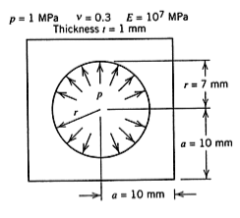
(10 points)
- Develop a 2D finite element model of the structure similar to the one shown in Figure 3.12-2 of the text-book. The geometric and material details are shown in the figure above. Use the CPS4I (Q6 with incompatible modes) element. Provide your model with all loads and boundary conditions completely defined in electronic format (CD or other).
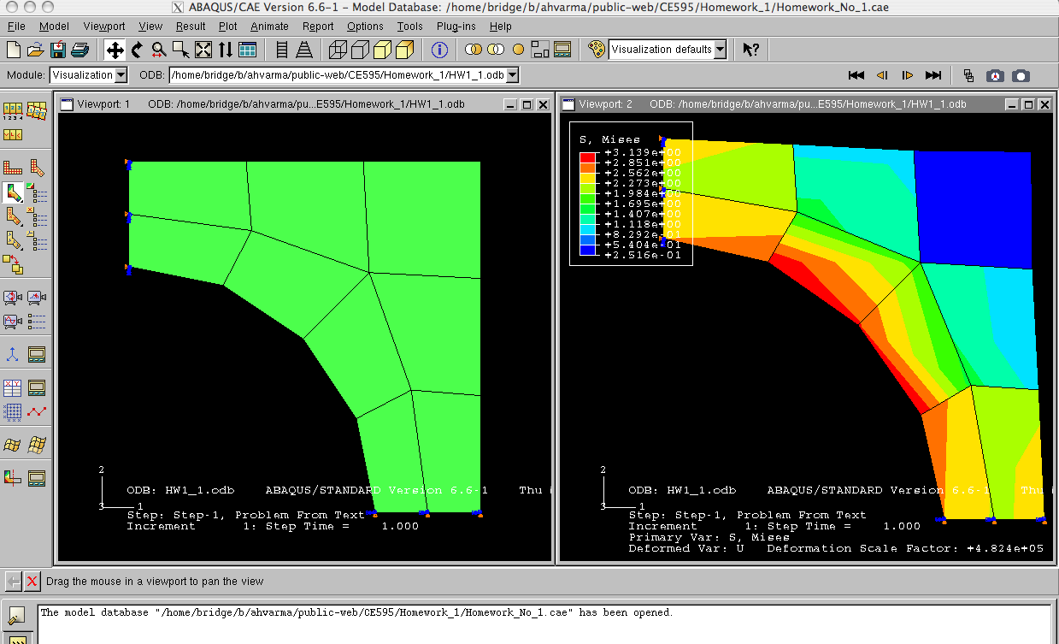

(10 points)
- Analyze the model.
  - Develop contour plots of the mises stress (σ_{e}) and indicate the maximum value and its location on the plot. Check your results with those reported in Figure 3.12-2c of text. If you are satisfied then continue with part III.
- Refine the mesh by increasing the number of elements from 1 to 4.
(10 points)
- Develop contour plots of the stresses (S11, S22, and S12). Make these banded contour plots with about 10 gradations between the limits. Do not average at the nodes.
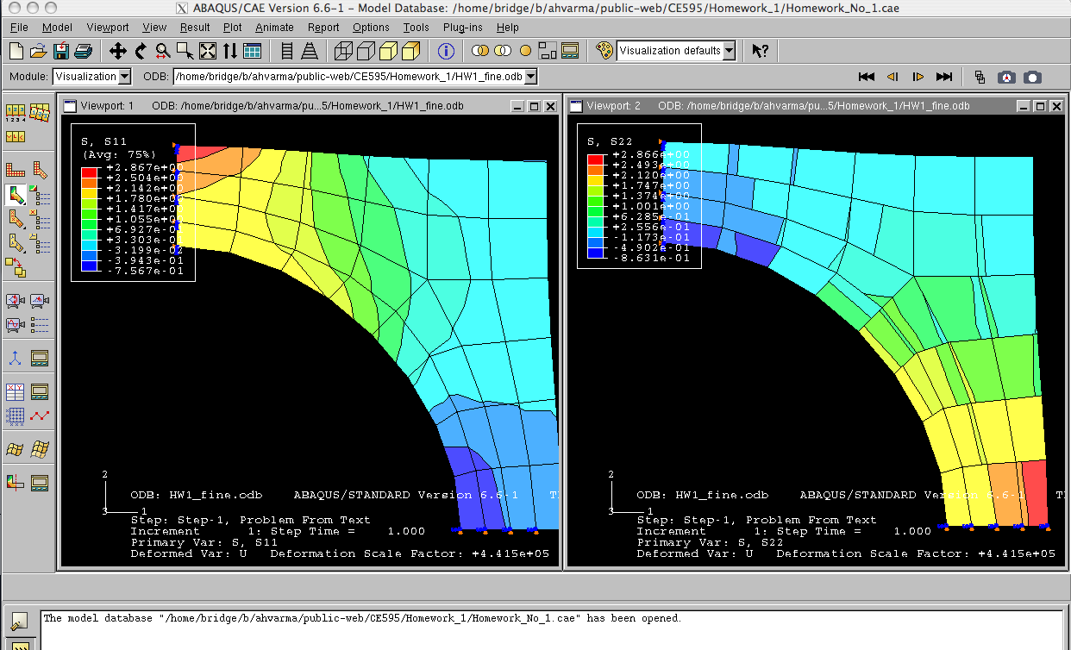
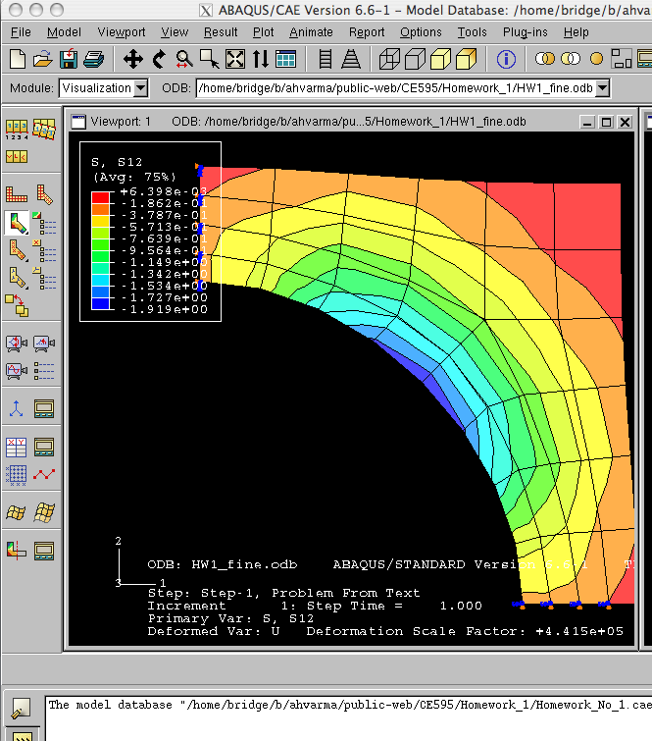
(10 points)
- Tabulate the displacements of points A, B, C, D, E, and F. Where does maximum displacement occur and what is its value.

Part Instance |  | Node ID | Element | U1 | U2 | UMAG
PART-1-1 | A | 11.00 | Elem-1 | 6.4834E-37 | 2.2647E-06 | 2.2647E-06
PART-1-1 | B | 9.00 | Elem-1 | 1.1052E-36 | 1.9495E-06 | 1.9495E-06
PART-1-1 | C | 2.00 | Elem-1 | 2.2648E-06 | 6.4925E-37 | 2.2648E-06
PART-1-1 | D | 5.00 | Elem-1 | 1.9496E-06 | 1.1051E-36 | 1.9496E-06
PART-1-1 | E | 1.00 | Elem-1 | 1.2528E-06 | 1.2526E-06 | 1.7716E-06
PART-1-1 | F | 7.00 | Elem-1 | 9.9910E-07 | 9.9913E-07 | 1.4130E-06

(10 points)
- Make a drawing of the model showing the maximum values of S11, S22, and S12. Indicate their values and directions on the drawing.

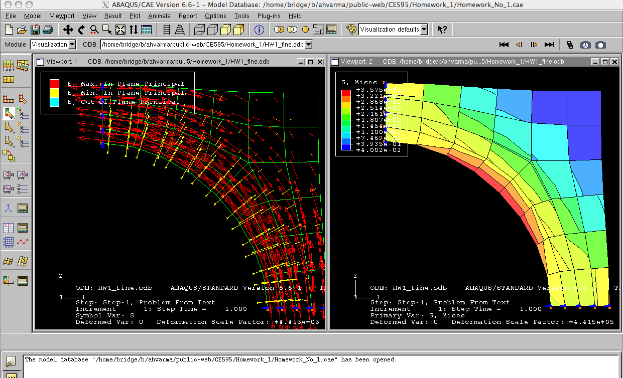
(5 points)
3.57262,
3.57453 ksi
- Develop contour plots of the mises stress (s_{e}) and indicate the maximum value and its location on the plot. Check your results with those reported in Figure 3.12-2c of text.

(5 points)
- Develop contour plots of the tresca stress and indicate the maximum value and location on the plot. How do the results compare with those from (d) above.

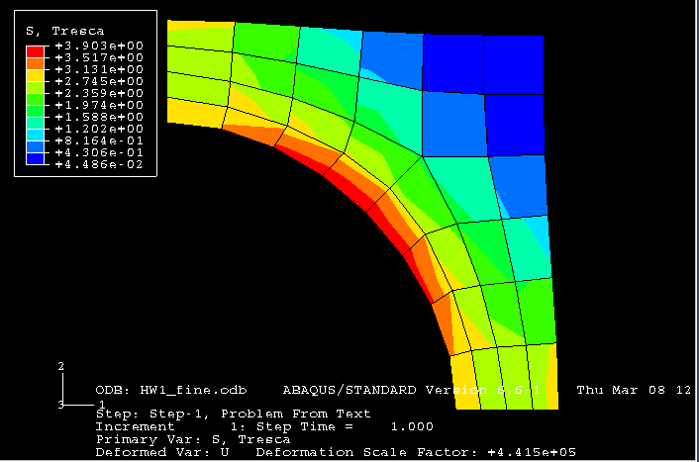
- The contours look similar but the values are slightly different. The max value of TRESCA stress is a little higher
3.89995
3.90253 ksi
3.89995
3.90253 ksi
(5 points)
  - Develop the vector (or symbol) plot of the principal stresses in the model. Do the results make sense with respect to the development of stresses in the model?
The principal stresses indicate the formation of radial and hoop principal stresses, which makes sense for the given problem with internal pressure. The maximum stress occurs at the point making 45º angle with respect to the origin of the hole.
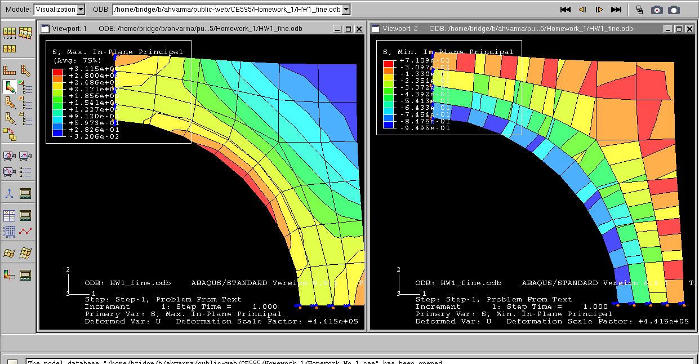

- (10 points)
- If the material is assumed to have yield stress of 227 MPa, what value of internal pressure will produce yielding? Why? Explain the basis of your answer.

If we assume the Von Mises yield criterion, then yielding will occur when the internal pressure is equal to (227/3.57453) = 63.5 MPa

If we assume the TRESCA yield criterion, then yielding will occur when the internal pressure is equal to (227/3.90253) = 58.167 MPa

The calculations assume linear elastic behavior, superposition of stresses, and that the stresses will scale linearly with the applied loading. Both the Von Mises and Tresca yield criteria are acceptable for steels, but Von Mises is preferred due to the smooth shape of the surface.

